7. CRIPT – ARITHMETIC PROBLEM
Aim:
To solve the Crypt Arithmetic Problem SEND + MORE = MONEY using the Backtracking Search algorithm in Artificial Intelligence.

Objective :
To assign a unique digit (0–9) to each letter such that the arithmetic equation
SEND + MORE = MONEY
is satisfied while ensuring that:
- Each letter represents a unique digit.
- No leading letter is assigned zero.
- The equation is mathematically correct.

Algorithm:

- Define the letters involved in the puzzle.
- Generate all possible digit assignments using permutations.
- Ensure that the leading letters (S and M) are not assigned zero.
- Convert the words SEND, MORE, and MONEY into their corresponding numeric values.
- Check whether the equation SEND + MORE = MONEY is satisfied.
- If a valid assignment is found, display the mapping and terminate.
- Otherwise, continue searching until all possibilities are exhausted.

Flowchart :

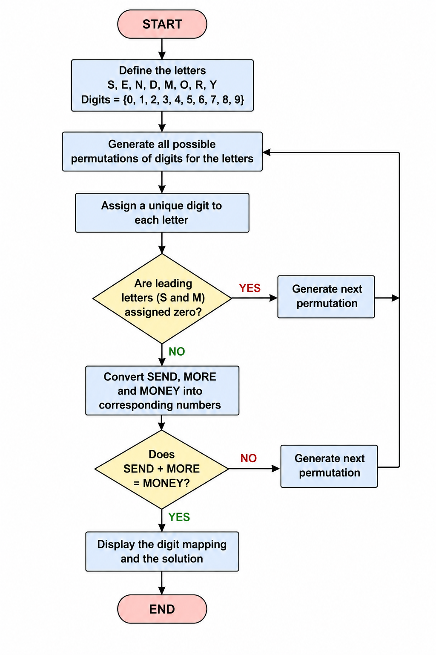

Code:

from itertools import permutations
def solve_cryptarithmetic():
letters = ('S', 'E', 'N', 'D', 'M', 'O', 'R', 'Y')
digits = range(10)
for perm in permutations(digits, len(letters)):
mapping = dict(zip(letters, perm))
if mapping['S'] == 0 or mapping['M'] == 0:
continue
SEND = (mapping['S'] * 1000 +
mapping['E'] * 100 +
mapping['N'] * 10 +
mapping['D'])
MORE = (mapping['M'] * 1000 +
mapping['O'] * 100 +
mapping['R'] * 10 +
mapping['E'])
MONEY = (mapping['M'] * 10000 +
mapping['O'] * 1000 +
mapping['N'] * 100 +
mapping['E'] * 10 +
mapping['Y'])
if SEND + MORE == MONEY:
print("Solution Found!\n")
print("Letter -> Digit Mapping")
for letter in letters:
print(f"{letter} = {mapping[letter]}")
print("\nVerification")
print(" SEND =", SEND)
print(" MORE =", MORE)
print("------ +")
print("MONEY =", MONEY)
return
print("No solution found.")
solve_cryptarithmetic()

Output:
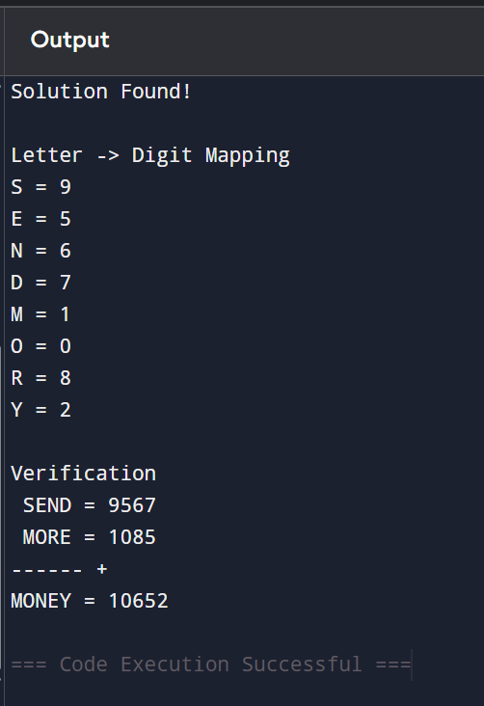
Result :

The Crypt Arithmetic Problem was successfully solved using the Backtracking Search algorithm. A unique digit was assigned to each letter while satisfying the equation:
9567 + 1085 = 10652
Thus, the solution was obtained successfully.

